JAYPEE INSTITUTE OF INFORMATION TECHNOLOGY, Noida

Department of CSE & IT



Bachelor of Technology, Semester IV

***METRO NAVIGATOR***

2019-2020

1. DEEKSHA VARMA-17103018 Submitted To

2. PRAGYA SHARMA-17103022 DEEPTI SINGH

3. PRATEEKSHA RAWAT-17103030

**INTRODUCTION**

**The project aims at calculating the shortest distance between any two**

**metro stations. It also calculates the amount that the traveller has to**

**pay. Also it calculates time taken to reach the required destination. The**

**user will input his start location and end location to see all travel**

**details.**

**Now a days people prefer to travel in metro, so this project will be**

**helpful to know details of the ride before actually travelling, this**

**makes their ride more convenient.**

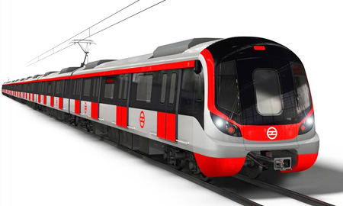

**DATA STRUCTURE USED**

**The basic data structures used in this project is graph, maps, greedy’s djikstras algorithm also some more primary data structures are used in this, such as array.**

**OOPS / C++ concepts to be used**

**Class diagram, relationships (association, aggregation and**

**composition), inheritance, polymorphism, templates, STL,**

**friend function, static function, file handling, exception handling,**

**etc.**